Joint Accreditation Statement

For Directly Provided Activities: In support of improving patient care, University of Arkansas for Medical Sciences is jointly accredited by the Accreditation Council for Continuing Medical Education (ACCME), the Accreditation Council for Pharmacy Education (ACPE), and the American Nurses Credentialing Center (ANCC) to provide continuing education for the healthcare team.

Credit Designation Statements

AMA Credit Designation Statement
The University of Arkansas for Medical Sciences designates this live activity for a maximum of 20.25 AMA PRA Category 1 CreditsTM. Physicians should claim only the credit commensurate with the extent of their participation in the activity.

ACPE Credit Designation Statement
These knowledge-based activities will provide pharmacists up to 20.25 contact hours or 2.025 CEU. CE credit information, based on verification of live attendance and completion of the program evaluation, will be provided to NABP within 60 days after the activity completion.

ANCC Credit Designation Statement
The University of Arkansas for Medical Sciences designates this live activity for a maximum of 20.25 ANCC contact hours. Nursing contact hours will be awarded for successful completion of program components based upon documented attendance and completion of evaluation materials.

AAPA Credit Designation Statement
The University of Arkansas for Medical Sciences has been authorized by the American Academy of PAs (AAPA) to award AAPA Category 1 CME credit for activities planned in accordance with AAPA CME Criteria. This activity is designated for 20.25 AAPA Category 1 CME credits. PAs should only claim credit commensurate with the extent of their participation.

CDR Credit Designation Statement
This program has been approved for 20.25 contact hours of continuing education for dietitians by the Academy of Nutrition and Dietetics. CPEUs awarded will be commensurate with participation in the activity. Learners should enter this activity as type 102 on Professional Development Portfolio (PDP) activity logs.

BOC Designation Statement
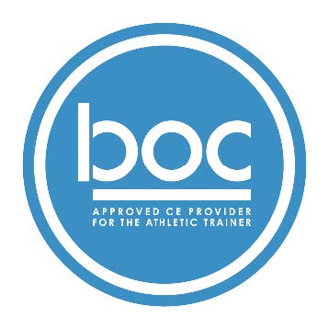
University of Arkansas for Medical Sciences (BOC AP#: 0000298) is approved by the Board of Certification, Inc. to provide continuing education to Athletic Trainers (ATs). This program is eligible for a maximum of 20.25 Category A hours/CEUs. ATs should claim only those hours actually spent in the educational program.

